2.a)Buck Converter Transfer Function

In this part, a buck converter transfer function is obtained analytically. In order to make the model realistic ESR values of both inductor and capacitor is added to converter schematic as seen in Figure xx. As marked in the schematic, there are two state variables in the buck converter namely inductor and capacitor current.

$\dot{X}=AX+BVd$ and Vo = C\*X where $X= \left[\begin{matrix}iL \\ Vc\end{matrix}\right]$ So, aim is finding A, B,C vectors.

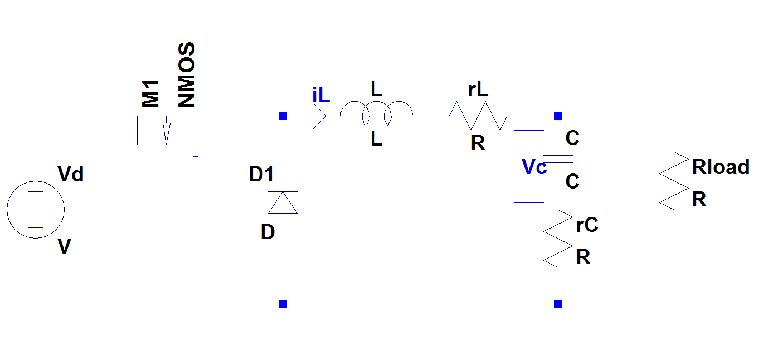 Figure xx: Realistic buck converter

*On State of buck converter*

As known, LCR circuit is connected to Vd through MOSFET in on state. Hence two mesh equations can be written such that one of them is covering outer mesh which consists of input voltage, inductor and load resistor and other one is covering capacitor and load resistor.

Kirchoff Voltage Law on outer mesh:

$-Vd+L*\dot{iL}+rL*iL+Rload*(iL-C*\dot{Vc})$ (1)

Kirchoff Voltage Law on small mesh:

$-Vc-C*\dot{Vc}*rC+Rload*(iL-C*\dot{Vc})$ (2)

From 2nd equation;

$\dot{Vc}=iL*\frac{Rload}{C\left(rC+Rload\right)}-Vc*\frac{1}{C\left(rC+Rload\right)}$ (3)

From 1st and 3rd equation;

$\dot{iL}= -iL*\frac{Rload*rC+Rload*rL+rC*rL}{L*\left(Rload+rC\right)}-Vc*\frac{Rload}{L*\left(Rload+rC\right)}+Vd*\frac{1}{L}$ (4)

Hence A1 and B1 matrices can be constructed as follows

$$A_{1}= \left[\begin{matrix}-\frac{Rload*rC+Rload*rL+rC*rL}{L*\left(Rload+rC\right)} & -\frac{Rload}{L*\left(Rload+rC\right)} \\ \frac{Rload}{C\left(rC+Rload\right)} & -\frac{1}{C\left(rC+Rload\right)}\end{matrix}\right]$$

$$B_{1}= \left[\begin{matrix}\frac{1}{L} \\ 0\end{matrix}\right]$$

Output voltage equation;

$$Vo=Rload*\left(iL-C*\dot{Vc}\right)=iL*\frac{Rload*rC}{Rload+rC}+Vc*\frac{Rload}{Rload+rC}$$

So; $C_{1}=\left[\begin{matrix}\frac{Rload*rC}{Rload+rC} & \frac{Rload}{Rload+rC}\end{matrix}\right]$

*Off State of buck converter*

At off state, LCR circuit is short circuited through diode. Note that off state is exactly same with on state with Vd short circuited. So A2 = A1 and B2 = 0. Also output voltage equation is same which yields C2 = C1.

Resultant matrices;

A = A1 = A2 B= B1\*D C= C1= C2

As ESR of the inductor and capacitor is usually in mΩ range and minimum Rload is about 1.8Ω a reasonable assumption can be done with Rload >>rC,rL also Rload>>rC+rL. Resultant matrices can be constructed as follows;

$A= \left[\begin{matrix}-\frac{rC+rL}{L} & -\frac{1}{L} \\ \frac{1}{C} & -\frac{1}{CR}\end{matrix}\right]$ $B= \left[\begin{matrix}\frac{1}{L} \\ 0\end{matrix}\right]*D$ $C= \left[\begin{matrix}rC & 1\end{matrix}\right]$

*Obtaining Transfer Function*

From Mohan’s book at page 325 this transfer function formula can be seen;

C:\Users\St\Desktop\mohan tf.png

By substituting matrices found before it can be expressed as follows;

$$Tp\left(s\right)= \left[\begin{matrix}rC & 1\end{matrix}\right]*{\left[\begin{matrix}s+\frac{rC+rL}{L} & \frac{1}{L} \\ -\frac{1}{C} & s+\frac{1}{CR}\end{matrix}\right]}^{-1}*\left[\begin{matrix}\frac{1}{L} \\ 0\end{matrix}\right]*Vd$$

Taking inverse of middle matrices;

$$Tp\left(s\right)= \left[\begin{matrix}rC & 1\end{matrix}\right]*\frac{1}{s^{2}+\frac{s}{CR}+s\frac{rC+rL}{L}+\frac{rC+rL}{LCR}+\frac{1}{LC}}\left[\begin{matrix}s+\frac{1}{CR} & -\frac{1}{L} \\ \frac{1}{C} & s+\frac{rC+rL}{L}\end{matrix}\right]*\left[\begin{matrix}\frac{1}{L} \\ 0\end{matrix}\right]*Vd$$

Hence;

$$Tp\left(s\right)=Vd\frac{1+s*rC*C}{LC(s^{2}+s(\frac{1}{CR}+\frac{rC+rL}{L})+\frac{rC+rL}{LCR}+\frac{1}{LC})}$$

Substituting numerical values; C =470 µF, L =1 mH, rC =10 mΩ, rL = 10 mΩ and R =1.8 Ω

$$Tp\left(s\right)=24\frac{1+s*4.7*{10}^{-6}}{470*{10}^{-9}(s^{2}+s(1182+20)+2.36*{10}^{4}+2.13*{10}^{6})}$$

Note that the terms results from rC and rL makes very small effect in denominator, but rC results a zero which may causes considerable differences at high frequencies. Bode plot of this transfer function is obtained using MATLAB, related result can be seen in Figure xx

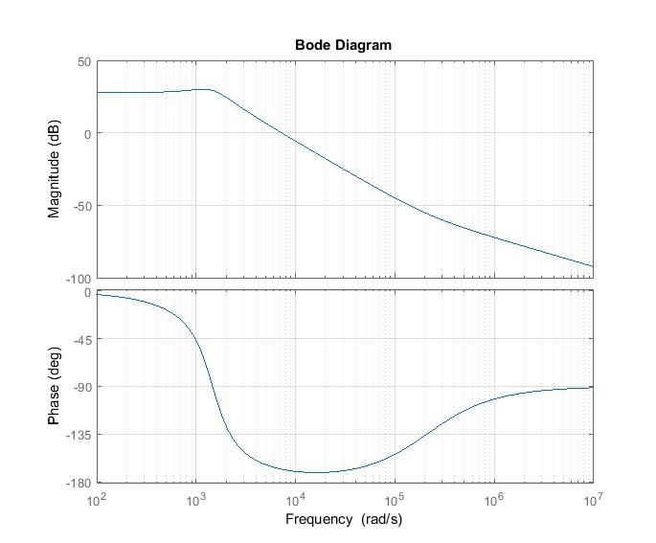

Figure xx: Bode plot of theoretical transfer function

Note that this transfer function has at most 15°-20° phase margin hence it should be improved in order to get better transient stability.